Assignment-1

DBMS

Mohammad Israr

GU13R0069

1. Creating A Database

CREATE DATABASE Israr;

This SQL query will create a database of name Israr.

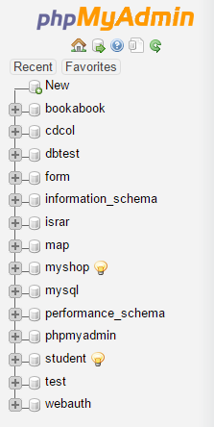

1. Creating A Table

Now we will create a table.

CREATE TABLE postman(postman_id int(100), name varchar(100), age int(100),Area varchar(100), ph_no int(10));

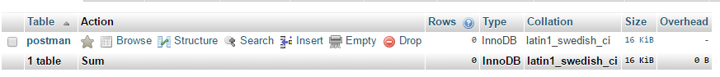

And the structure of this table is this:

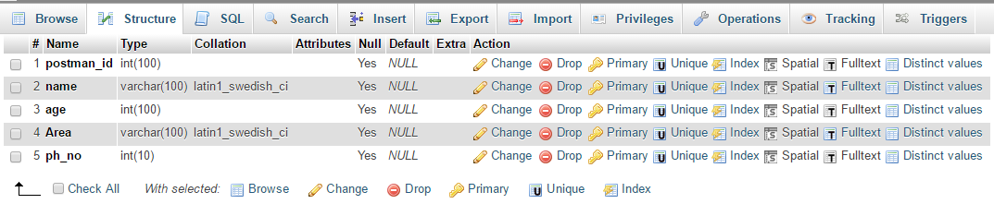

1. Inserting Values In The Table

INSERT INTO `postman`(`postman_id`, `name`, `age`, `Area`, `ph_no`) VALUES (1, 'Maaz', 32, 'Ring_Road', 1010121525);

INSERT INTO `postman`(`postman_id`, `name`, `age`, `Area`, `ph_no`) VALUES (2 , 'Rupesh', 29, 'Ring_Road', 1010121475);

INSERT INTO `postman`(`postman_id`, `name`, `age`, `Area`, `ph_no`) VALUES (3 , 'Aamir', 32, 'Madanpuri', 1450121525);

INSERT INTO `postman`(`postman_id`, `name`, `age`, `Area`, `ph_no`)VALUES (4 , 'Raj', 35, 'Link_Road', 4910121525);

INSERT INTO `postman`(`postman_id`, `name`, `age`, `Area`, `ph_no`) VALUES (5 , 'MAryam', 29, 'GT_Road', 2310121525);

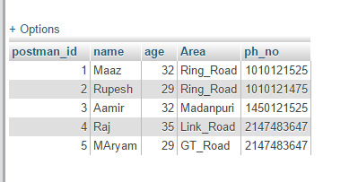

1. Select From Table

SELECT * FROM `doctor`;

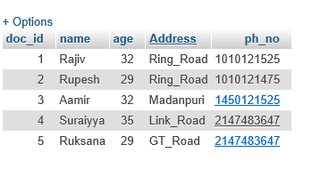

1. Deleting From Table

DELETE FROM `doctor`;

This will delete all the record in the table.

1. Updating A Record

UPDATE `postman` SET `postman_id`=4,`name`='Farheen',`age`=35,`Area`='Link_Road',`ph_no`=123456799 WHERE age= 35;

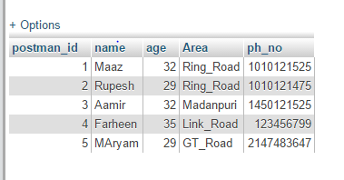

1. Selecting From Table

SELECT `postman_id`, `name`, `age`, `Area`, `ph_no` FROM `postman` WHERE age = 32;

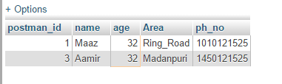

1. AND

SELECT * FROM `postman` WHERE age= 32 AND area = 'Ring_road';

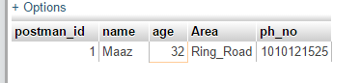

1. OR

SELECT * FROM `postman` WHERE age= 32 OR area = 'Ring_road';

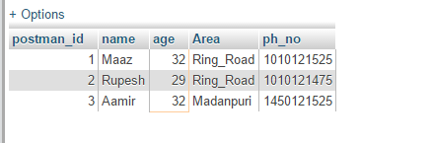

1. Between

SELECT * FROM `postman` WHERE postman_id BETWEEN 2 AND 4;

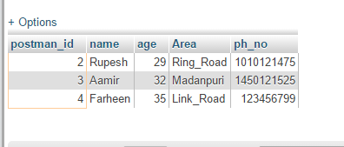

1. LIKE

SELECT * FROM `postman` WHERE area LIKE '%road%';

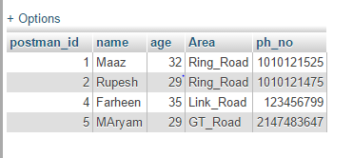

1. ORDER BY

SELECT * FROM `postman` ORDER BY age;

